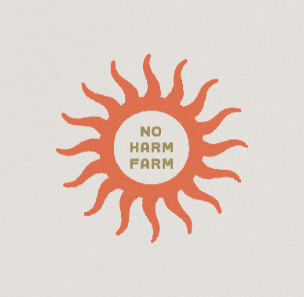
2023 VOLUNTEER APPLICATION
Volunteers must be at least 18 years old to volunteer at Stahl’s No Harm Farm Animal Sanctuary. Children between the ages of 12 and 17 may be permitted to volunteer with special interest groups or organizations on specific projects.
Name ___________________________________ Date of Application_________________________
Address__________________________________ City/State/Zip ______________________________
Home Phone ______________________________ Cell Phone_________________________________
Email ___________________________________ Work Phone_______________________________
Are you over 18 years old? _____________________________
Emergency Contact_______________________ Relationship_________________________________
Emergency Contact Phone__________________
Alternate Phone______________________________
Our mission at Stahl’s No Harm Farm Animals Sanctuary is to provide sanctuary to farm animals that are or are at risk of becoming neglected, abused and/or exploited. We will provide a healing, loving atmosphere to farm animals that are surrendered, rescued and/or abandoned.
We will attempt to re-home appropriate animals where they will be loved and free from harm.
We believe all sentient beings deserve a life filled with peace, love and compassion. Through education, promoting veganism and advocating for animal rights, we aim to inspire society to change their view of farm animals from one that is oppressive to one that views all animals as sentient beings and worthy of a peaceful life free from harm.
VISION
We vision a peaceful world where farm animals are no longer bred into existence for humankind to exploit, abuse or neglect, a world where animals can live free from harm and cruelty.
Although we promote a vegan lifestyle, our volunteers do not need to be vegan.
2/23

How did you hear about Stahl’s No Harm Farm Animal Sanctuary? __________________________________________________________________________________________________________________________________________________________________________Describe present and previous volunteer jobs: ______________________________________________________________________________________________________________________________________________________________________________________________________________________________________________________________ Skills, training or hobbies you would like to share with us (i.e. farm animal handling, maintenance, building, landscaping) _______________________________________________________________________________________________________________________________________________________________________________________________________________________________________________________________ What is you availability? Please be as specific as possible.
__________________________________________________________________________________________________________________________________________________________________________ Are you available weekly or as needed ?
_________________________________________________________________________________________________________________________________________________________________________
Have you ever been convicted of a charge involving the abuse and/or neglect of an animal? If so, please explain:
__________________________________________________________________________________________________________________________________________________________________________

I give my permission to Stahl’s No Harm Farm Animal Sanctuary to verify the above information. I understand that this application does not guarantee acceptance into Stahl’s No Harm Farm Volunteer Program.
_____________________________________________________________________________________
Volunteer Signature Date

1675 MIDWAY ST NW UNIONTOWN, OH 44685 (330) 800-8742 stahlsnoharm@gmail.com

